1. Retrieve all columns from the "employees" table.

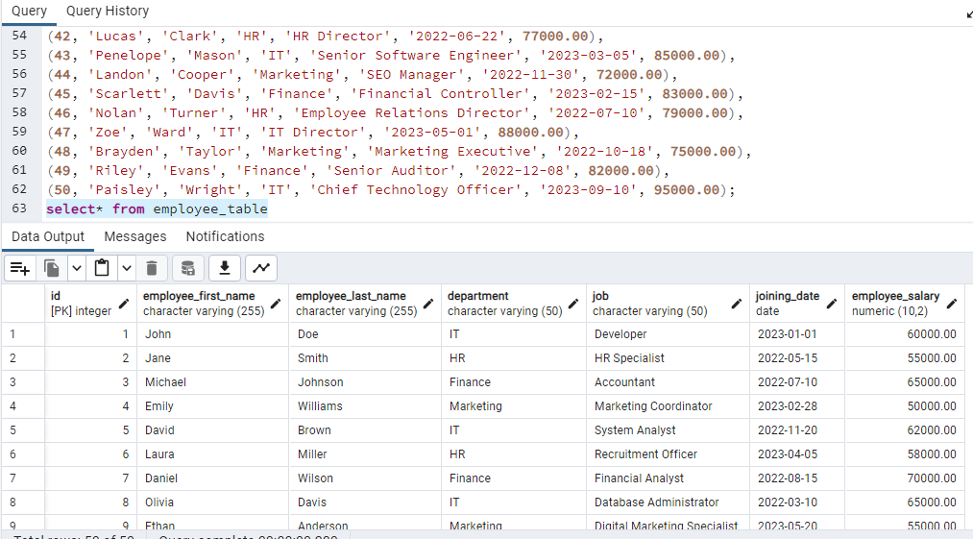

1. Display the first name, last name, and salary of all employees.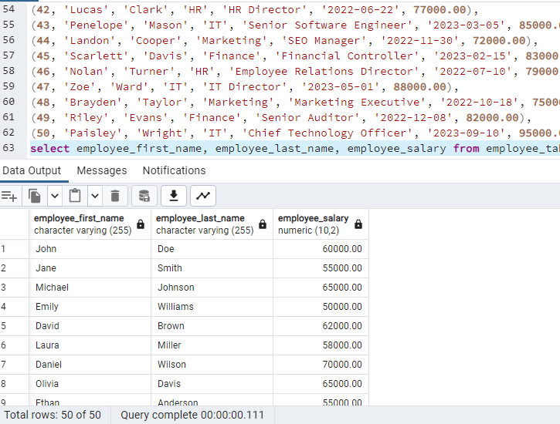
2. Find the employees whose salary is greater than 50000.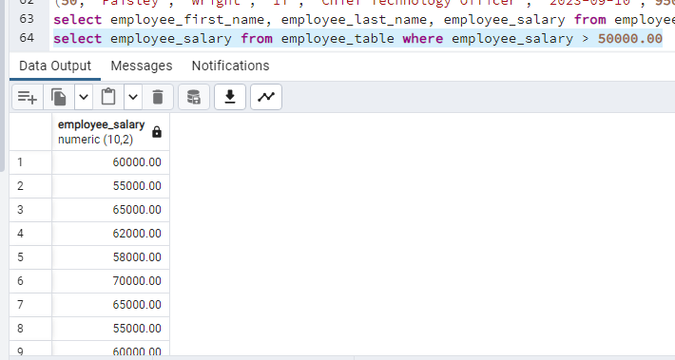
3. List the employees whose last name starts with 'S'.

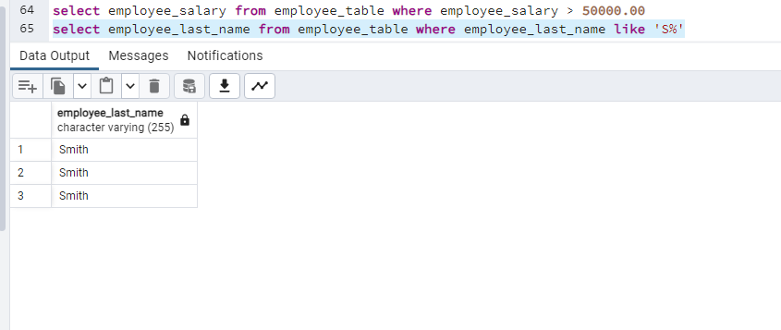

1. Show the details of employees who joined after January 1, 2022.

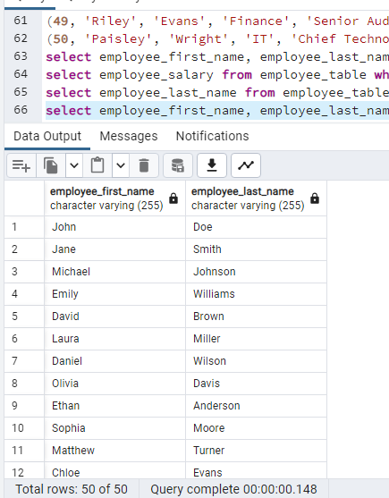

1. Display the unique job titles in the "jobs" table.
2. Count the number of employees in the "employees" table.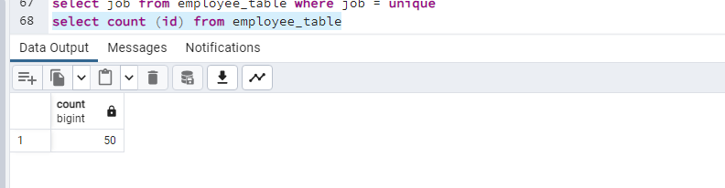
3. Calculate the average salary of all employees.

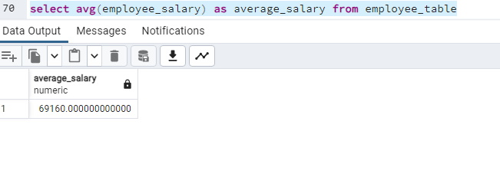

1. Find the highest salary in the "employees" table.

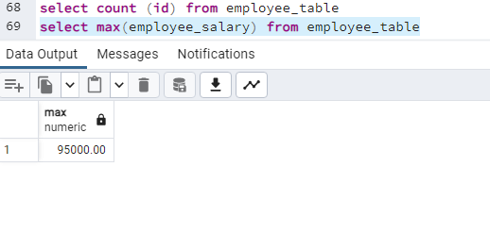

1. List the employees who work in the 'IT' department.

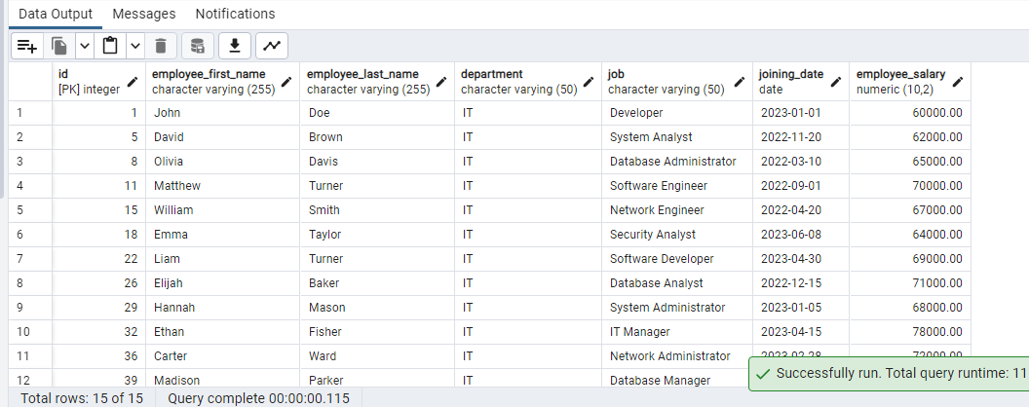

1. Retrieve the employees whose job title contains 'Manager'.

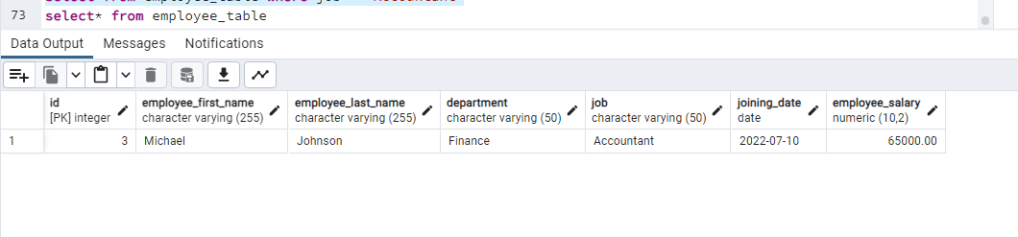

1. Show the first and last names of employees in uppercase.

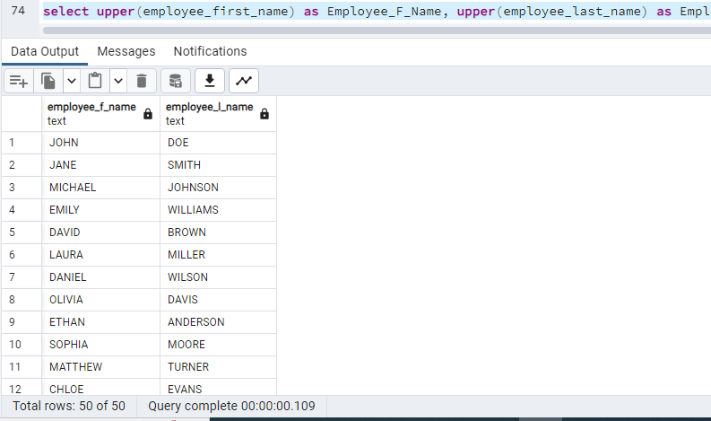

1. Display the employees whose last name ends with 'son'.

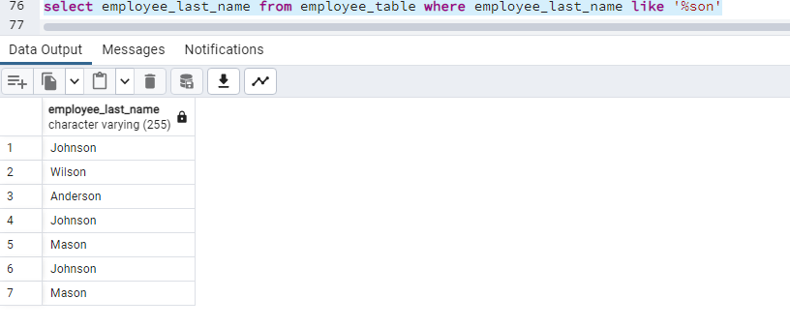

1. Find the total number of employees for each department. 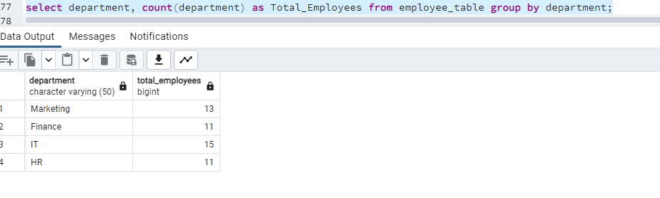
2. Calculate the total salary expenditure for the company.

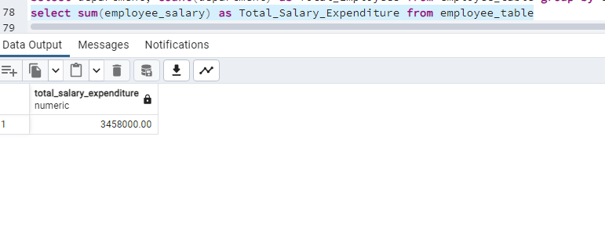

1. List the employees who have a salary between 40000 and 60000.

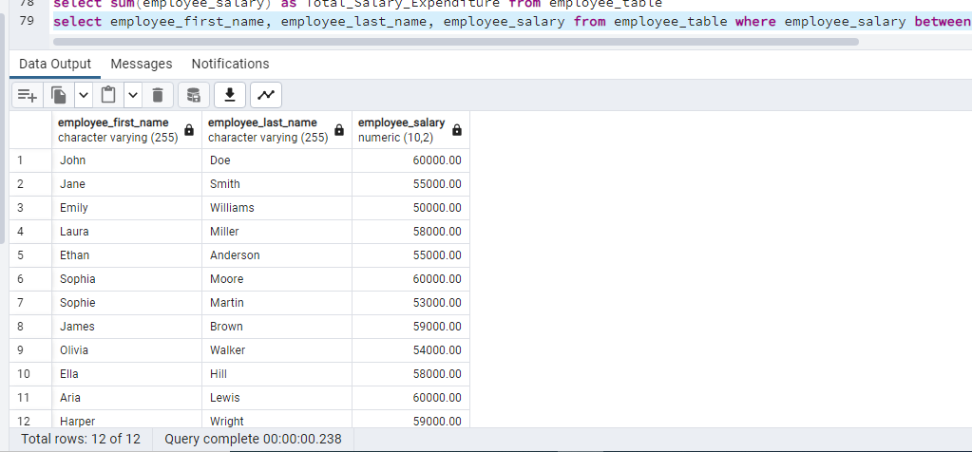

1. Find the average salary for each department.

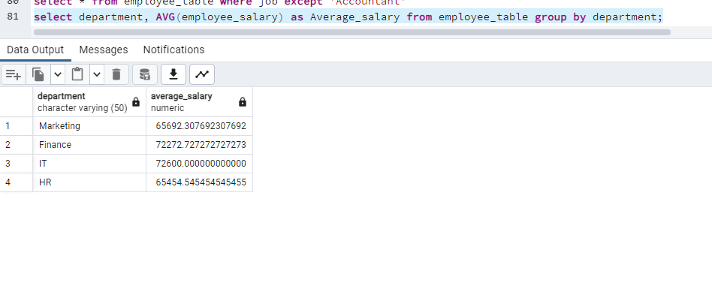

1. Show the employees whose first name contains exactly five characters.

